**JOB SEARCH WEBSITE**

## Objective:

The aim of the web site for job search is to find best jobs out there. It is greatly useful for the unemployed people. This site helps in finding the best job for the person based on their skills. All the job seekers and the job providers will be benefited. Their informations will be stored in the databases.

## Existing System:

* The existing system do not provide the option for Job providers to filter those candidates who are having the required skillset.
* The existing System do not have the facility for mobile alerts that makes the job seekers and job providers to stay updated.

## Proposed System:

The development phase of new job search website contains the following activities, which try to automate the entire process keeping in the view of database integration approach.

* This Site can provide the an option of sending recruitment information to the Job providers
* This website can provide the mail alert and mobile alert facility for the jobseekers
* Administrator can control both job provider’s and as well as jobseeker’s information to ensure the security.

## Number of Modules

After careful analysis the website has been identified to be presented with the following modules:

1. Administrator
2. Jobseeker
3. Job provider

## Administrator:

This module is has the facility of viewing the information about job providers and jobseekers .This is the middle man service for the users. Administrator accept the information of job provider’s needs and send the job information to Jobseeker by using mobile alert and through mail alert also. Here the administrator has a challenging work of figuring out best jobs for the jobseekers and send them alerts.

## Jobseeker

This module is has the capability to register as new user and use the services provided. All the user information that are collected while browsing are saved in the database.

## JobProvider :

This module will have the ability for sending the job information through administrator which will be viewed by the job seeker’s.

## Software Requirements :

Operating System : Windows XP/2003 or Linux User Interface : HTML, Eclipse,RAD

Client-side Scripting : JavaScript Programming Language : Java SE and Java EE Web Applications : JDBC, Servlets, JSP

Database : DB2-express-c Server Deployment : Websphere

**Hardware Requirements:**

Processor : Pentium IV

Hard Disk : 40GB

RAM : 512MB or more

# SDLC METHDOLOGIES

The SRS document plays a vital role in the development of the software project as this document is carried as reference through out the projectIt will be used by the delevopers, testers and other stakeholders.We can not make any changes to this document, if in case changes are to be made we might undergo a proper process of change which will be done after approval.

SPIRAL MODEL was defined by Barry Boehm in his 1988 article, “A spiral Model of Software Development and Enhancement. This model employes the iterative approach to solve problems.

The iterations may take from 6 months to 2 years period. Each phase starts with a design goal and ends with a client reviewing the progress.Analysis and engineering efforts are applied at each phase to reach the end goal of the project.

The steps for Spiral Model can be given as follows:

* The new system requirements are defined in as much details as possible. This usually involves interviewing a number of users representing all the external or internal users and other aspects of the existing system.
* A preliminary design is created for the new system.
* A first prototype of the new system is constructed from the preliminary design. This is usually a scaled-down system, and represents an approximation of the characteristics of the final product.
* A second prototype is evolved by a fourfold procedure:
  1. Evaluating the first prototype in terms of its strengths, weakness, and risks.
  2. Defining the requirements of the second prototype.
  3. Planning an designing the second prototype.
  4. Constructing and testing the second prototype.
* At the customer option, the entire project can be aborted if the risk is deemed too great. Risk factors might involved development cost overruns, operating-cost miscalculation, or any other factor that could, in the customer’s judgment, result in a less-than-satisfactory final product.
* The existing prototype is evaluated in the same manner as was the previous prototype, and if necessary, another prototype is developed from it according to the fourfold procedure outlined above.
* The preceding steps are iterated until the customer is satisfied that the refined prototype represents the final product desired.
* The final system is constructed, based on the refined prototype.
* The final system is thoroughly evaluated and tested. Routine maintenance is carried on a continuing basis to prevent large scale failures and to minimize down time.

**The following diagram shows how spiral model acts like:**

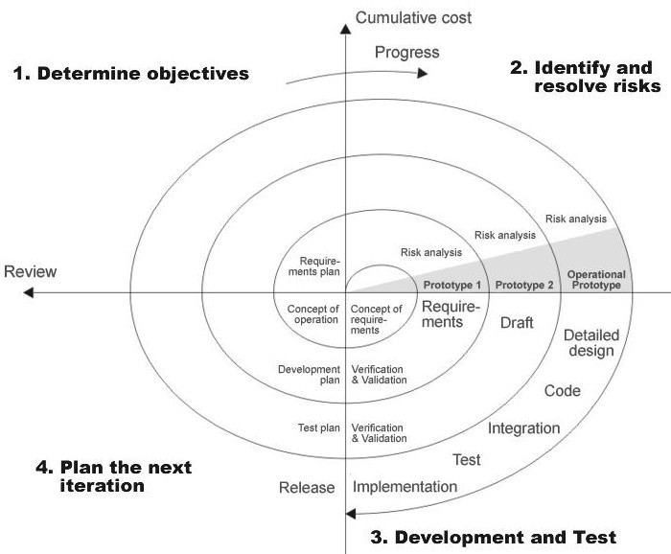

**Fig 1.0-Spiral Model**

**ADVANTAGES:**

* Estimates(i.e. budget, schedule etc .) become more relistic as work progresses, because important issues discoved earlier.
* It is more able to cope with the changes that are software development generally entails.
* Software engineers can get their hands in and start woring on the core of a project earlier.

# INPUT DESIGN

Input design is a part of overall system design. The main objective during the input design as given below:

* To produce cost-effective method of input
* To achieve the highest possible level of accuracy.
* To ensure that the input is acceptable and understood by the user.

## Input States:

The main input stages can be listed as below:

* + Data recording
  + Data transcription
  + Data conversion
  + Data verification
  + Data control
  + Data transmission
  + Data validation
  + Data correction

**INPUT TYPES:**

It is necessary to determine the various types of input. Inputs can be categorized as follows:

* + External Inputs which are prime inputs for the system.
  + Internal Inputs, which are user communications with the systems.
  + Operational, which are computer department’s communications to the system?
  + Interactive, which are inputs entered during a dialogue.

## Input Media:

At this stage choice has to be made about the input media.To conclude about the input media consideration has to be given to:

* + Type of Input
  + Flexibility of Format
  + Speed
  + Accuracy
  + Verification methods
  + Rejection rates
  + Ease of correction
  + Storage and handling requirements
  + Security
  + Easy to use
  + Portability

Keeping in view the above description of the input types and input media, it can be said that most of the inputs are of the form of internal and interactive. As input data is to be directly keyed in by the user, the keyboard can be considered to be the most suitable input device.

**OUTPUT DESIGN:**

Outputs from computer systems are required primarily to communicate the results of processing to users. They are also used to provide a permanent copy of the results for later consultation. The various types of outputs in general are:

* External Outputs, whose destination is outside the organization,.
* Internal Outputs whose destination is within organization and they are the
* User’s main interface with the computer.
* Operational outputs whose use is purely within the computer department.
* Interface outputs, which involve the user in communicating directly with User Interface.

## Output Definition:

The outputs should be defined in terms of the following points:

* + Type of the output
  + Content of the output
  + Format of the output
  + Location of the output
  + Frequency of the output
  + Volume of the output
  + Sequence of the output

It is not always desirable to print or display data as it is held on a computer. It should be decided as which form of the output is the most suitable.

For Example

* Will decimal points need to be inserted
* Should leading zeros be suppressed

**OUTPUT DESIGN:**

In the next stage it is to be decided that which medium is the most appropriate for the output. The main considerations when deciding about the output media are:

* The suitability for the device to the particular application.
* The need for a hard copy.
* The response time required.
* The location of the users
* The software and hardware available.

Keeping in view the above description the project is to have outputs mainly coming under the category of internal outputs. The main outputs desired according to the requirement specification are: The outputs were needed to be generated as a hot copy and as well as queries to be viewed on the screen. Keeping in view these outputs, the format for the output is taken from the outputs, which are currently being obtained after manual processing. The standard printer is to be used as output media for hard copies.

# APPLICATION DEVELOPMENT:

## N-Tier Applications:

N-Tier Applications can easily implement the concepts of Distributed Application Design and Architecture. The N-Tier Applications provide strategic benefits to Enterprise Solutions. While 2-tier, client-server can help us create quick and easy solutions and may be used for Rapid Prototyping, they can easily become a maintenance and security night mare

The N-tier Applications provide specific advantages that are vital to the business continuity of the enterprise. Typical features of a real life n-tier may include the following:

* Security
* Availability and Scalability
* Manageability
* Easy Maintenance
* Data Abstraction

The above mentioned points are some of the key design goals of a successful n-tier application that intends to provide a good Business Solution.

## Definition:

Simply stated, an n-tier application helps us distribute the overall functionality into various tiers or layers:

* + Presentation Layer
  + Business Rules Layer
  + Data Access Layer
  + Database/Data Store

Each layer can be developed independently of the other provided that it adheres to the standards and communicates with the other layers as per the specifications.

This is the one of the biggest advantages of the n-tier application. Each layer can potentially treat the other layer as a ‘Block-Box’.

In other words, each layer does not care how other layer processes the data as long as it sends the right data in a correct format.

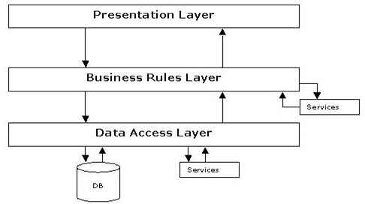

## Fig 1.1-N-Tier Architecture

1. **The Presentation Layer:**

Also called as the client layer comprises of components that are dedicated to presenting the data to the user. For example: Windows/Web Forms and buttons, edit boxes, Text boxes, labels, grids, etc.

## The Business Rules Layer:

This layer encapsulates the Business rules or the business logic of the encapsulations. To have a separate layer for business logic is of a great advantage. This is because any changes in Business Rules can be easily handled in this layer. As long as the interface between the layers remains the same, any changes to the functionality/processing logic in this layer can be made without impacting the others. A lot of client-server apps failed to implement successfully as changing the business logic was a painful process.

## The Data Access Layer:

This layer comprises of components that help in accessing the Database. If used in the right way, this layer provides a level of abstraction for the database structures. Simply put changes made to the database, tables, etc do not affect the rest of the application because of the Data Access layer. The different application layers send the data requests to this layer and receive the response from this layer.

1. **The Database Layer:**

This layer comprises of the Database Components such as DB Files, Tables, Views, etc. The Actual database could be created using SQL Server, Oracle, Flat files, etc.

In an n-tier application, the entire application can be implemented in such a way that it is independent of the actual Database. For instance, you could change the Database Location with minimal changes to Data Access Layer. The rest of the Application should remain unaffected

# PERFORMANCE REQUIREMENTS:

Performance is measured in terms of the output provided by the application. Requirement specification plays an important part in the analysis of a system. Only when the requirement specifications are properly given, it is possible to design a system, which will fit into required environment. It rests largely in the part of the users of the existing system to give the requirement specifications because they are the people who finally use the system. This is because the requirements have to be known during the initial stages so that the system can be designed according to those requirements. It is very difficult to change the system once it has been designed and on the other hand designing a system, which does not cater to the requirements of the user, is of no use.

The requirement specification for any system can be broadly stated as given below:

* 1. The system should be able to interface with the existing system
  2. The system should be accurate
  3. The system should be better than the existing system

The existing system is completely dependent on the user to perform all the duties.

# FEASIBILITY REPORT:

Preliminary investigation examine project feasibility, the likelihood the system will be useful to the organization. The main objective of the feasibility study is to test the Technical, Operational and Economical feasibility for adding new modules and debugging old running system. All system is feasible if they are unlimited resources and infinite time. There are aspects in the feasibility study portion of the preliminary investigation:

* Technical Feasibility
* Operation Feasibility
* Economical Feasibility

## Technical Feasibility

The technical issue usually raised during the feasibility stage of the investigation includes the following:

* Does the necessary technology exist to do what is suggested?
* Do the proposed equipments have the technical capacity to hold the data required to use the new system?
* Will the proposed system provide adequate response to inquiries, regardless of the number or location of users?
* Can the system be upgraded if developed?
* Are there technical guarantees of accuracy, reliability, ease of access and data security?

Earlier no system existed to cater to the needs of ‘Secure Infrastructure Implementation System’. The current system developed is technically feasible. It is a web based user interface for audit workflow at NIC-CSD. Thus it provides an easy access to the users. The database’s purpose is to create, establish and maintain a workflow among various entities in order

to facilitate all concerned users in their various capacities or roles. Permission to the users would be granted based on the roles specified. Therefore, it provides the technical guarantee of accuracy, reliability and security. The software and hard requirements for the development of this project are not many and are already available in-house at NIC or are available as free as open source. The work for the project is done with the current equipment and existing software technology. Necessary bandwidth exists for providing a fast feedback to the users irrespective of the number of users using the system.

## Operational Feasibility

Proposed projects are beneficial only if they can be turned out into information system. That will meet the organization’s operating requirements. Operational feasibility aspects of the project are to be taken as an important part of the project implementation. Some of the important issues raised are to test the operational feasibility of a project includes the following: -

* Is there sufficient support for the management from the users?
* Will the system be used and work properly if it is being developed and implemented?
* Will there be any resistance from the user that will undermine the possible application benefits?

This system is targeted to be in accordance with the above-mentioned issues. Beforehand, the management issues and user requirements have been taken into consideration. So there is no question of resistance from the users that can undermine the possible application benefits.

The well-planned design would ensure the optimal utilization of the computer resources and would help in the improvement of performance status.

## Economic Feasibility

A system can be developed technically and that will be used if installed must still be a good investment for the organization. In the economical feasibility, the development cost in creating the system is evaluated against the ultimate benefit derived from the new systems. Financial benefits must equal or exceed the costs. The system is economically feasible. It does not require any addition hardware or software. Since the interface for this system is developed using the existing resources and technologies available at NIC, There is nominal expenditure and economical feasibility for certain.